* PENETRATION TESTING PRACTICE LAB - VULNERABLE APPS / SYSTEMS: <https://www.amanhardikar.com/mindmaps/Practice.html>
* These security testing tools or utilities are of great help when you want to do security tests for your web application or any software based on the context.

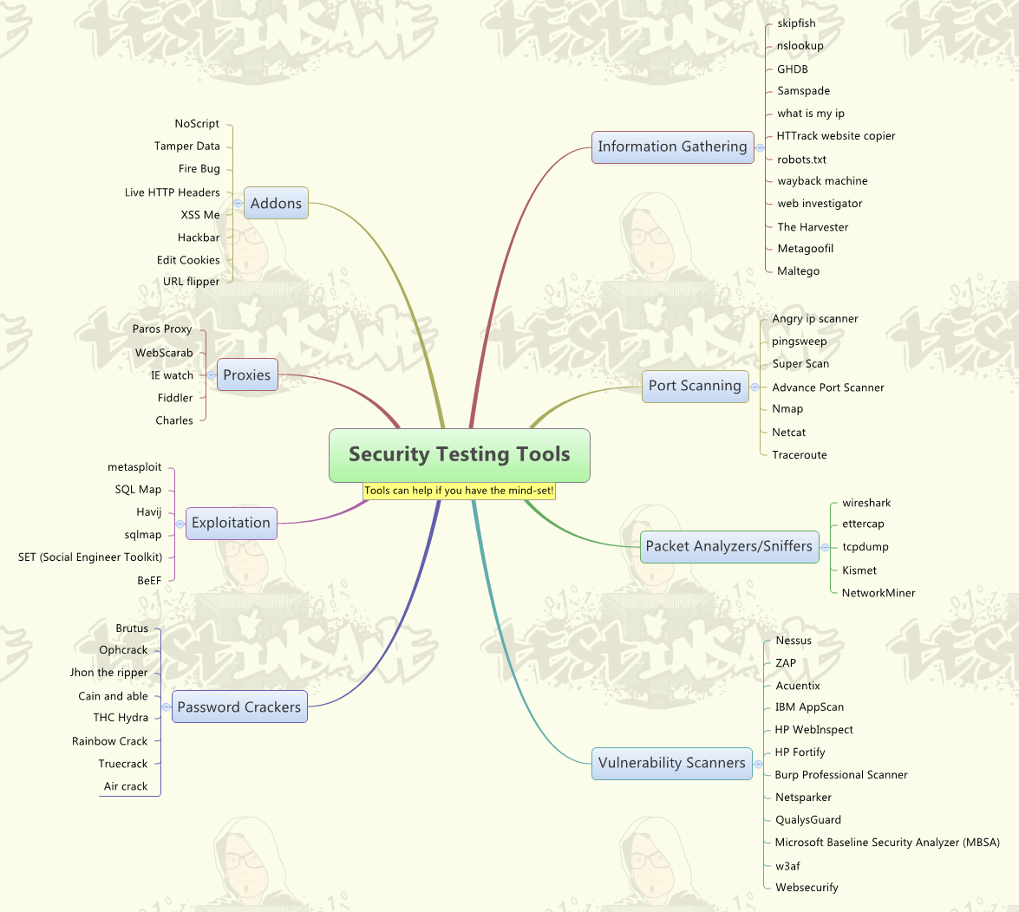

* Penetration Testing Mind map:

A mind map is a diagram that visually represents a central topic, and any points that flow from it, which can be ideas, thoughts or strategies. Mind maps can be freehand structures sketched out on preferably a large sheet of paper or whiteboard, or created from customizable shape templates in an app. This format makes testing with mind maps a helpful activity for garnering raw ideas before they are sifted and structured.

